Doc Fritchey TU Members Only Raffle – 2016

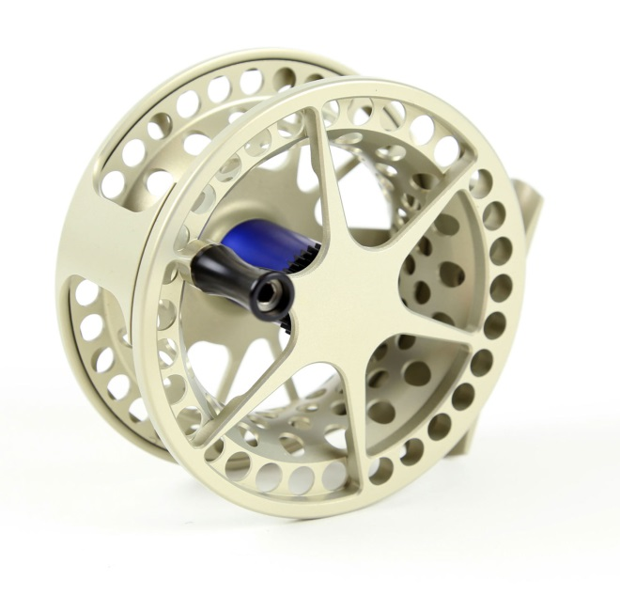
PRIZE #1

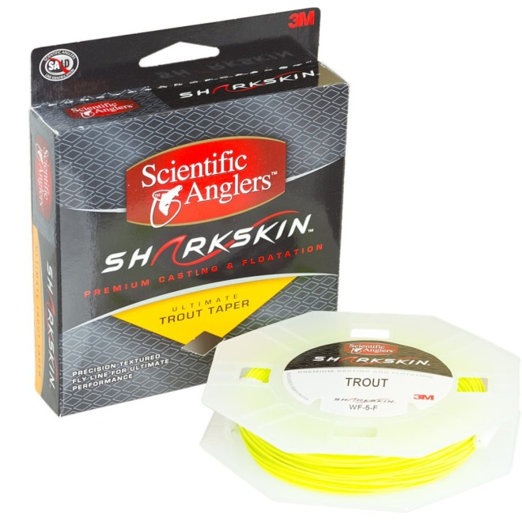
PRIZE #2
Lamson Litespeed Series IV Fly Reel – LS1.5 for 3, 4 or 5 wt. Line
For years an iconic ultra-large arbor reel, Litespeed has now been refined for even higher retrieve rate, improved ergonomics, easier line management and less mass. Everything that was achieved in Gen 3 LS has been pushed farther. Narrower drag geometry has translated into a flatter spool surface for less knuckle dragging. A more aggressive drag knob has been made ... well, more aggressive. Structural refinements such as the curved arbor have made a light reel even lighter, and this curved arbor (which we introduced in 1998) stores backing into a "diameter well" and keeps "working line" at a maximum radius to optimize everything we love about large arbor reels.

Sharkskin Line of Your Choice
- Sharkskin technology for the ultimate in casting and floatation
- Delicate and accurate
- Welded streamlined loop - slick and strong - for easy connections and seamless fishing (front)
- Longer head for optimum combination of distance and control
- Sharkskin microtextured surface on specially formulated 3M PVC integrated with patented Advanced Shooting Technology

