Lower Snitz Creek Restoration Project: Hershey Property
North Cornwall Township, Lebanon County, Pennsylvania

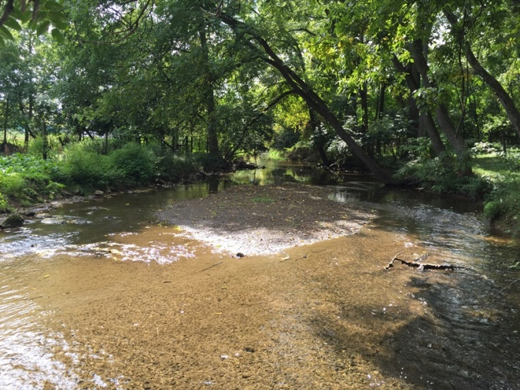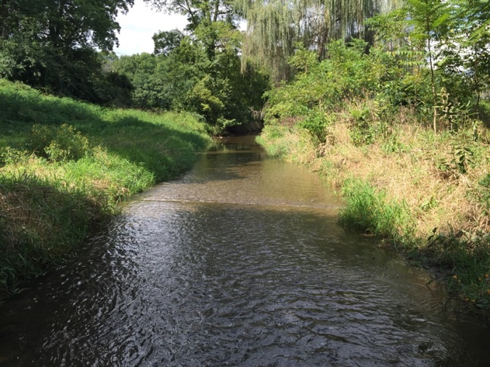

September 2016

Lower Snitz Creek Restoration Project: Hershey Property
North Cornwall Township, Lebanon County, Pennsylvania

Prepared for
Doc Fritchey Chapter of Trout Unlimited

Prepared by

Clear Creeks Consulting

September 2016

Background Information
Snitz Creek is a tributary to the Quittapahilla Creek in Lebanon County, Pennsylvania. Both are in the Susquehanna River Basin and they drain to the Chesapeake Bay. The headwaters of Snitz Creek arise in southern Lebanon County near the Borough of Cornwall and the stream flows north to join the Quittapahilla Creek just west of the City of Lebanon. The drainage area of Snitz Creek is 12.4 mi² (Pennsylvania Department of Environmental Protection, 2001).
Land use in the watershed is predominately agricultural with pasture land and row crops occupying most of the watershed. Residential development is increasing and in 2011, 37 percent of the watershed was classified as “developed”¹.
Snitz Creek is protected for the uses TSF (Trout Stocking) and MF (Migratory Fishes) (Pennsylvania Department of Environmental Protection, 2016a). Normally, the stream is stocked with trout three times a year.
The Snitz Creek watershed has been designated as “impaired” by the Pennsylvania Department of Environmental Protection (Pennsylvania Department of Environmental Protection, 2016b). Causes for the Snitz Creek impairment are listed as pathogens and nutrients. In 2000, a Total Maximum Daily Load evaluation listed the Quittapahilla Creek as impaired from sediment (Pennsylvania Department of Environmental Protection, 2000). Sediment is also a concern throughout the Snitz Creek watershed, especially along lower Snitz Creek.
To address some of these problems, the Doc Fritchey Chapter of Trout Unlimited has targeted a section of Lower Snitz Creek on the Lilly and Mel Hershey property for a proposed restoration project.
Existing Conditions
Historically, the Hershey property has been used as a farm, and cattle were pastured in the fields adjacent to the creek. Currently, the farming operations have been reduced, but land on both sides of the creek is currently leased and used to pasture horses. The horses have complete access to the creek on the west side (no fence) and intermittent access (fence in disrepair) on the east side.
A stream assessment was conducted along the project area by Clear Creeks Consulting in September 2016: For purposes of the assessment as well as restoration design, the Project Area was divided into an Upper and Lower Reach. The Upper Reach starts approximately 100 feet upstream of the property boundary between the Swiss Premium Dairy Property and the Hershey Property and ends 500 feet downstream at the Hershey’s driveway bridge crossing. The lower reach of the project starts at the driveway bridge crossing and ends 700 feet downstream. The first 100 Feet of the upper reach is owned by the Swiss Premium Dairy.
A summary of the stream assessment data and maps showing existing conditions is included in the Appendix. The following summary and photos illustrate the problems along the Project Area.
Existing conditions along these reach include an over-wide channel cross-section, bank erosion, undercut and falling trees, aggradation and heavy sedimentation. In-stream habitat is very limited. The majority of the project area is composed of long, flat, featureless pools and glides. The few riffles that exist are almost completely embedded with fine sediments. Pools are generally shallow with no overhead cover and few hiding or resting places for fish. Some pools have more than a foot of organic muck and fine sediments along their bottom.
Horse trails traverse the channel at numerous locations. As a result of the unlimited livestock access, streambanks have been trampled leaving a major portion of the project area wide and shallow.
With the exception of areas protected by bedrock outcrops, the project area exhibits bank erosion along much of its length. Although the riparian area has some mature trees, a large portion of the streambank trees are severely undercut with leaning or in danger of falling into the channel. Invasive plant species including Oriental Bittersweet, Tartarian Honeysuckle, Tree of Heaven and Multiflora Rose are preventing native plants from thriving.
In its current unstable condition, this reach of Lower Snitz Creek provides very little habitat for aquatic insects or fish and is a source of sediment for downstream reaches along the Quittapahilla Creek. Because of these problems, the Doc Fritchey Chapter of Trout Unlimited and our partners are proposing a stream rehabilitation project for the lower end of Snitz Creek.
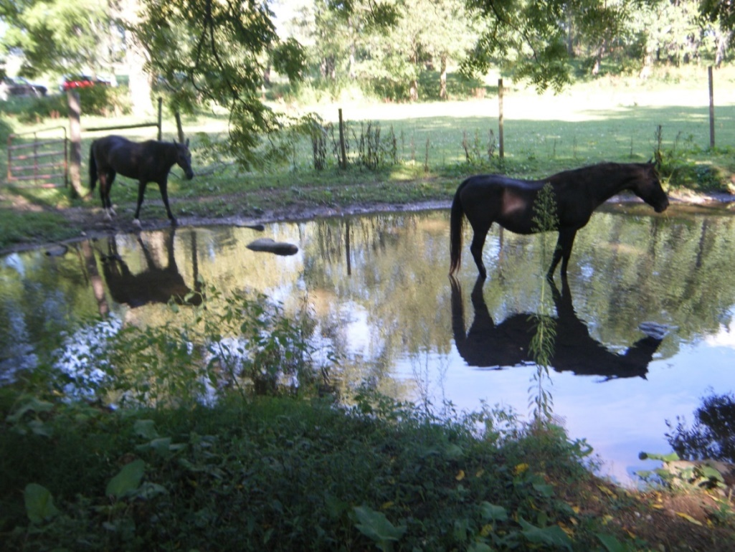
Fig. 1 – Horses in Snitz Creek, immediately upstream from the Hershey’s driveway.

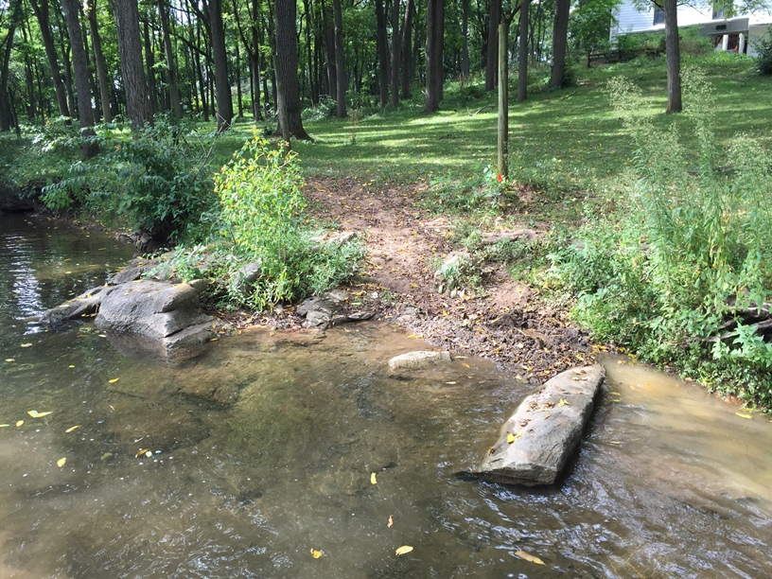
Figs. 2 and 3 – Horse trails and trampled banks along the upper reach of the Project Area
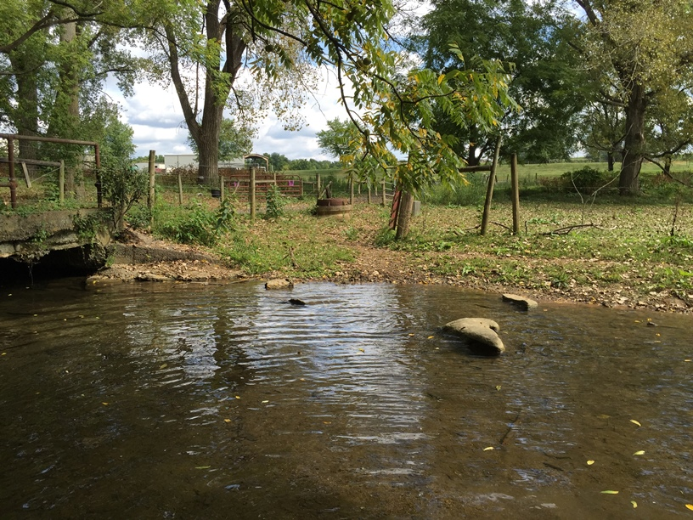
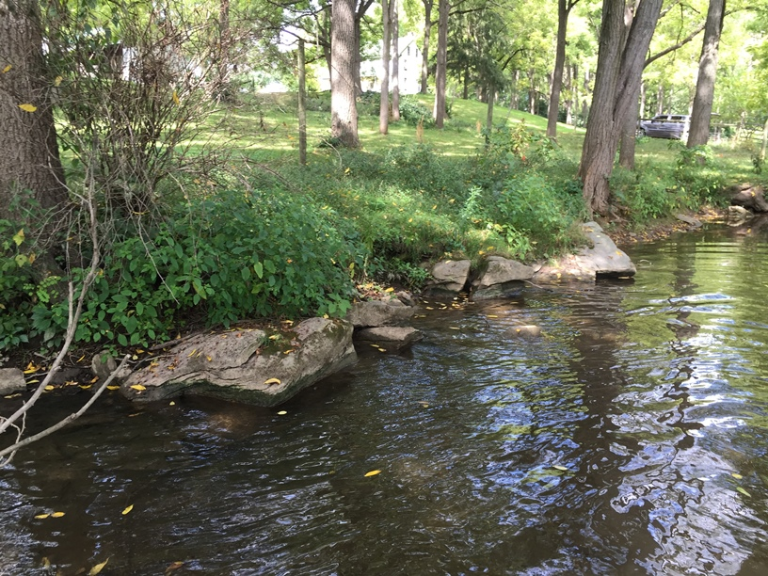
Fig. 4 – Exposed bedrock along stable banks
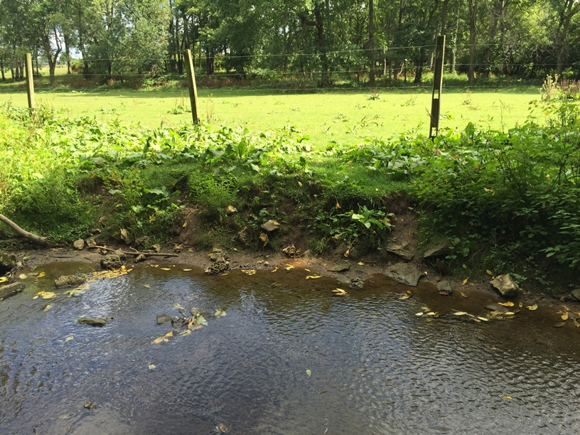
Fig. 5 – Streambank erosion is evident along upper reach.
Note lack of woody vegetation and poor ground cover.

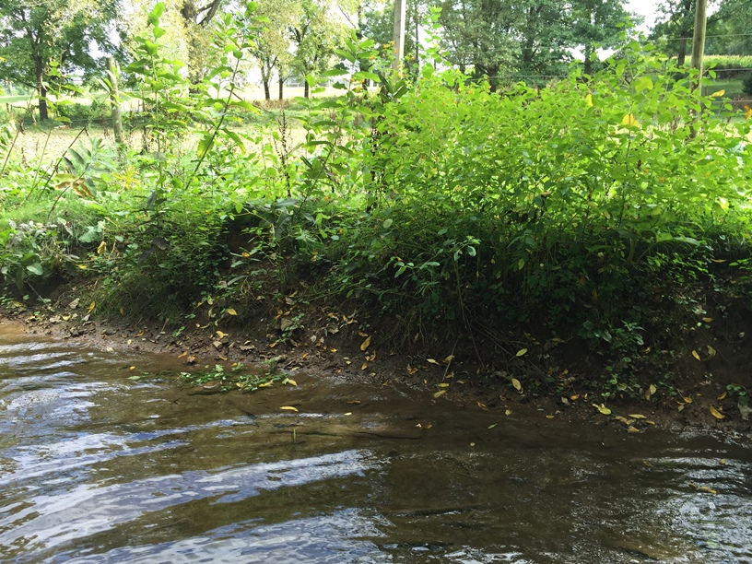
Fig. 6 – Streambank erosion is evident along upper reach.
Note lack of woody vegetation and poor ground cover.

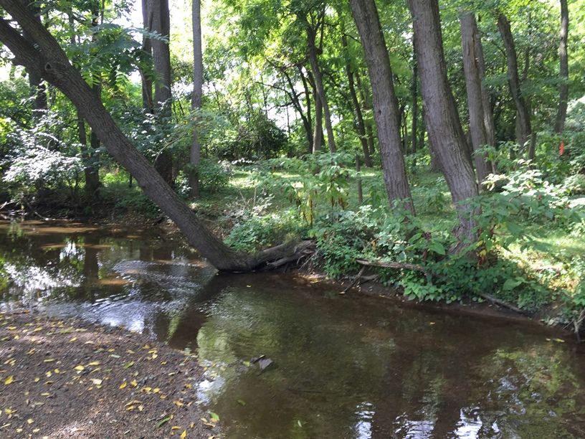
Fig. 7 – Undercut and leaning trees
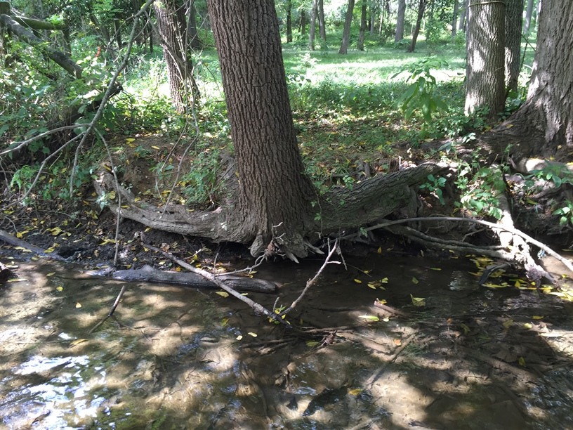
Fig. 8 – Undercut and leaning trees
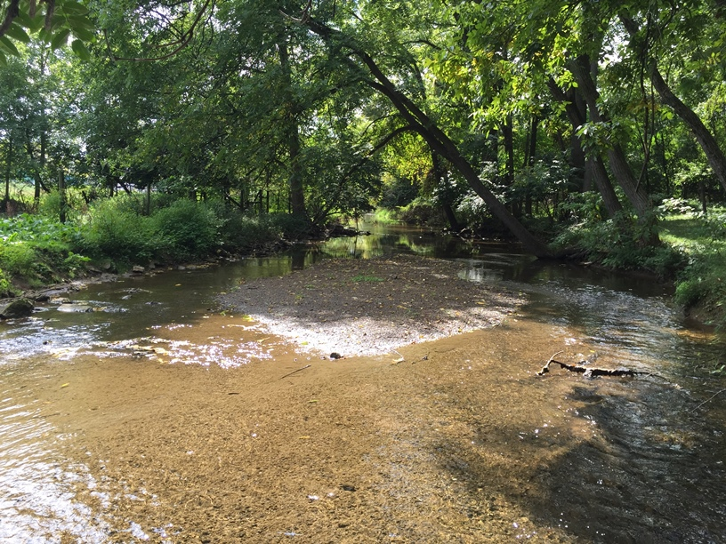
Fig. 9 – Large mid-channel bar along upper reach

Restoration Objectives
- Improve in-stream habitat to support aquatic insects and fish, with a particular emphasis on trout.
- Reduce streambank erosion and sedimentation along this reach of Snitz Creek.
Restoration Approach
This project proposes to restore 1,200 linear feet of Snitz Creek. The restoration design includes the following components:

- Stabilize streambanks to reduce erosion.
- Reconstruct streambanks to protect existing streambank trees that are in jeopardy of falling into and across the stream.
- Narrow the bankfull and baseflow channel to increase sediment transport, stream depth and water velocity and reduce sunlight impinging on the stream.
- Install in-stream habitat structures that will provide cover and resting places for trout.
- Provide long-term stabilization with native trees and shrubs throughout.
- Install fencing along unfenced pasture areas and repair existing fencing to keep horses and other livestock out of the stream.
- Install a new stabilized livestock crossing.
- Remove invasive plant species.

The proposed channel cross-sectional dimensions were developed by surveying a stable reach located approximately 300 feet upstream of the Project Area on the Swiss Premium Dairy Property (Fig. 10). Design plans are included in the Appendix.

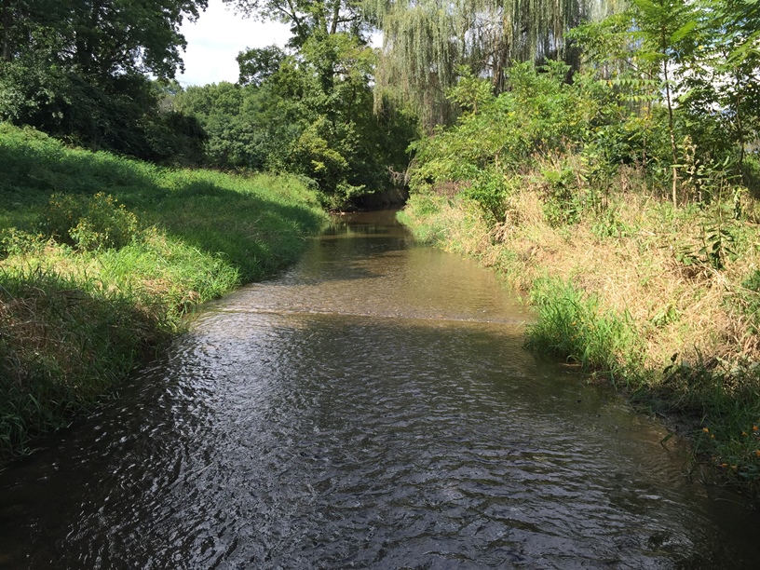
Fig. 10 – Stable reach upstream of Project Area
Existing Conditions Morphological Data
- Project Reaches
Upper Reach X-Section 1
- Bankfull
Cross-sectional Area = 56.7 ft²
Width = 34.2 ft.
Mean Depth = 1.7 ft.
Max Depth = 2.3 ft.
Wetted Perimeter = 35.9 ft.
Hydraulic Radius = 1.6 ft.
Width/Depth Ratio = 20.6
Entrenchment Ratio = 5.8

Lower Reach X-Section 2
- Bankfull
Cross-sectional Area = 52.8 ft²
Width = 38.3 ft.
Mean Depth = 1.4 ft.
Max Depth = 1.9 ft.
Wetted Perimeter = 38.6 ft.
Hydraulic Radius = 1.4 ft.
Width/Depth Ratio = 27.7
Entrenchment Ratio = 2.2

Design Reference
- Stable Reach
X-Section 3
- Bankfull
Cross-sectional Area = 23.1 ft²
Width = 19.2 ft.
Mean Depth = 1.2 ft.
Max Depth = 1.6 ft.
Wetted Perimeter = 20.3 ft.
Hydraulic Radius = 1.1 ft.
Width/Depth Ratio = 16
Entrenchment Ratio = 7.8

