Women’s Conservation/Fly Fishing Program 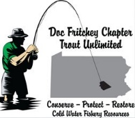

To further carry on the mission of Trout Unlimited the Doc Fritchey Chapter has expanded its educational offerings to include a Women’s Conservation/Fly Fishing Program. The program will be held at 11:30 AM on June 10, 2018 on a private property along Clark’s Creek. The program is open to a limited number of women who have:
- an interest in conservation
- expressed an interest in fly fishing
- the desire to join and participate in the Doc Fritchey Chapter of Trout Unlimited
This 3.5 hour event will introduce women to the various aspects of conservation with a focus on the basic aspects of fly fishing. We will have educational and practical stations set up staffed by experienced fly fishermen and women to cover the following topics:

- Personal equipment selection: waders, boots, vests, hats, sunglasses.
- Trout habits and food, insects, fly tying
- Fly fishing equipment: rod, reel, line, tippet, knots
- Casting techniques
At the conclusion of the sessions the participants will have the opportunity for an informal session with the session facilitators and other chapter members, snacks and an opportunity to fish with a fly fishing mentor on Clarks Creek or the pond. The stream will be stocked with trout by our Chapter for the enjoyment of the participants.
This event will be both educational and fun and serve as an introduction to conservation and fly fishing. There is no cost to the participants as the entire event (including rods, reels and flies, hand out materials and snacks) will be funded by our Chapter. A one-day educational fishing license will be provided by the Pa Fish and Boat Commission to participants (students) during the event.
For more information and to register for the event e-mail Chuck Swanderski at: docfritcheytumembership@gmail.com.
Participants will be limited to ensure a quality program.
INSTRUCTORS Amy and Amidea
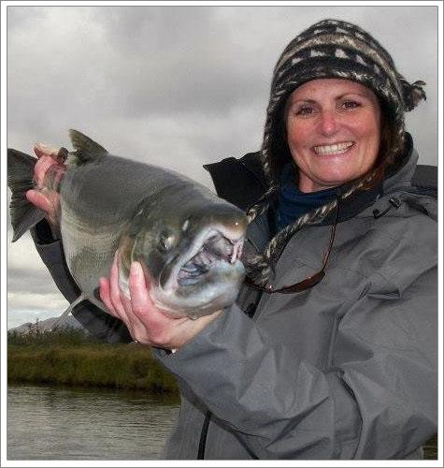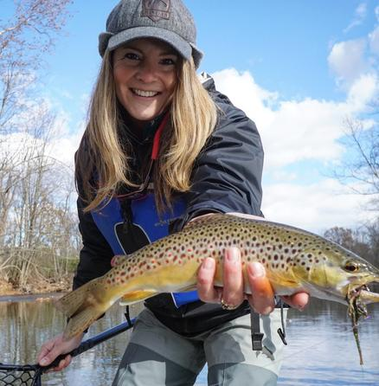
And members of the Doc Fritchey Chapter of Trout Unlimited

