Rich DiStanislao - The Hendrickson Mayfly

With the advent of snowmelt and the start of green woodland undergrowth comes the anticipation of trout season in Pennsylvania. Among the first of the classic mayfly emergences is the Ephemerella Subvaria, commonly referred to as the “Hendrickson”. These beautiful mayflies are typically seen on the water from early to mid-April, peaking around mid-May. They are well-distributed throughout Pennsylvania and New York trout streams. Overcast, misty days always seem to produce the best periods for catching a hatch. At hatch time, the Hendrickson nymphs (easily imitated with a size 12 hare’s ear nymph pattern) swim to the surface of the stream in mid-afternoon to shed their shucks and emerge as duns (subimagoes), and the trout can turn to feeding voraciously on the surface for these, taking both the crippled emergers and the newly hatched dun. The male and the female duns are somewhat easy to distinguish, as the males are a bit larger and dark reddish in color, with dark smoke-colored wings, easily imitated on a size 12 hook, while the female is a pinkish tan color with the same dark wings, best presented on a size 14 hook. As if this wonderful event can’t seem to get any better, it gathers a repeat surface eruption performance in the evening with the spinner fall. The spinners are a reddish-brown body with clear wings, on a size 12 or 14 light wire hook.
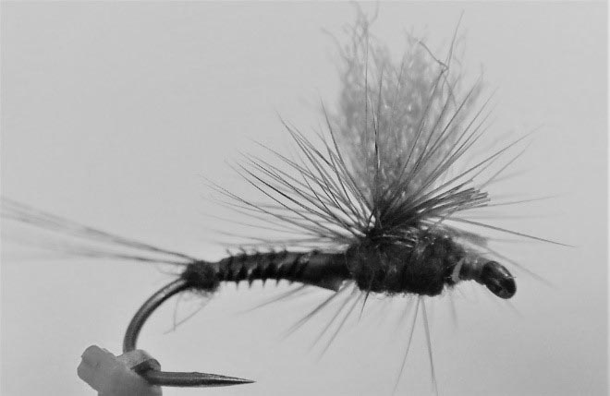
The Hendrickson Mayfly

My favorite pattern for the Hendrickson is the parachute dun. Here is the pattern I prefer to tie:
Hook: Dry fly hook, size 12, barbless (Tiemco model 900 or Mustad 94845 or similar hook)
Thread: Rusty orange 8/0 unithread or 12/0 Veevus
Tails: 3 or 4 fibers from a brownish-gray Coq de Leon feather, each tail fiber slightly longer than the hook shank. Before tying in the tail fibers, first build up a small ball of superfine reddish-brown poly at the bend of the hook.

Then tie the coq de leon fibers on the top of the hook shank, wrapping your tying thread into the ball, pressing the tail fibers into the ball. This will cause the tail fibers to separate a bit and angle upwards slightly
Body: For the abdomen, use a turkey biot, rusty colored, soaked for a few minutes in water to make it pliable. Tie the biot in by the tip, with the darker flue pointing up and away from the tyer, so as you wrap, the flue will create a segmented body appearance. Wrap the biot from the tail toward the eye, about 2/3 the length of the hook shank and tie off.
Wing: Dark dun colored poly yarn (I like Hi-Viz fibers) for a parachute post
Hackle: Medium dun-grizzly dry fly hackle. Tie in at the base of the parachute post, but don’t wrap until after dubbing the thorax
Thorax: Reddish brown superfine poly, same as the ball tied in at the tail. Build the thorax around the parachute post, dub forward up toward the eye, leaving enough hook shank to anchor the hackle.
Now wind the hackle around the parachute post, making about 4 turns. Tie off the hackle feather near the eye of the hook, leaving enough room to build a small head at the eye.
When finished, trim the parachute wing to length, roughly as long as the hook shank.

