Please Join Us!
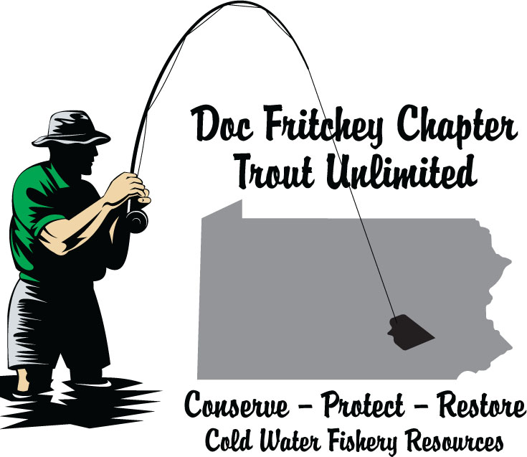

Doc Fritchey Chapter
Summer Picnic

Tuesday, July 23, 2019
5:30 to Sunset in Quittie Creek Nature Park in Annville
(The picnic will take place on the large lawn near the main parking lot)

In addition to a hot and cold buffet picnic – with cold beverages - (catered by the Chapter’s leadership team), we have recruited three of our chapter’s board members to give fly casting and fishing lessons.

Cyndi Camp and Rich DiStanislao will give fly casting lessons (group and/or one-on-one) from 6:00 PM until 7:00 PM. The chapter owns a good supply of teaching fly rods so there is no need to bring a fly rod, unless you want to fish the Quittie before the picnic starts.

Dr. Jim Suleski will give an in-stream demonstration on various wet-fly-fishing techniques.
Jim will be in the water (starting at 6:00 PM) and will teach various nymphing and wet fly-fishing techniques to those of us standing on the shore. This should be a great opportunity to learn some new (under-the-surface) techniques.

Cost: $10.00 for first person. $5.00 for additional family members/significant others
Everyone receives a raffle ticket at sign-in

Raffle: A custom-built 9 ft, 4-wt fly rod; a TFO Lefty Kreh, 9 ft, 8-wt fly rod; a Fly Logic FLP 3,4,5 reel with backing and fly line; and an on-the stream lesson with Dr. Jim Suleski. Must be present to win!

Please bring your own Chairs and Tables (there are a limited number of picnic tables in Quittie Creek Nature Park, so we need you to bring your own chairs and tables, large or small. Please note that alcoholic beverages are not permitted in Quittie Creek Nature Park. We are providing cold non-alcoholic beverages!

Obviously, we need to know who’s planning to attend, so please use the form below to register for the picnic. Mail your forms and checks (made payable to Doc Fritchey TU) to:
Steve Vegoe, 10 Oak Knoll Circle, Lebanon, PA 17042-9483. You will receive an email confirmation.

Doc Fritchey Summer Picnic Registration – July 23, 2019 – First ticket $10.00, extra tickets $5.00

Name(s)

Address

Email Address

Phone Number __________________________

Enclosed is my check in the amount of $___________ for ______ tickets

Checks Payable to Doc Fritchey TU - Mail to: Steve Vegoe, 10 Oak Knoll Circle, Lebanon, PA 17042-9483

